**ISCSI_LINUX PARTITION**

**Iscsi-server**

add 3hdd and 1GB ram 1 core

**Iscsi-client**

add 1hdd and 1gb ram 1 core

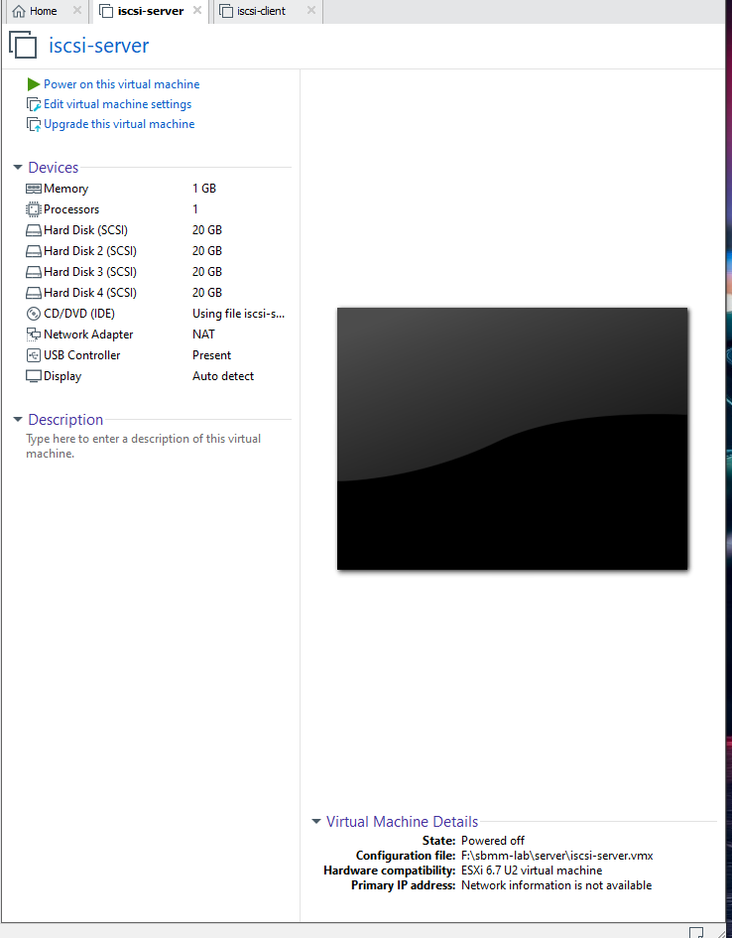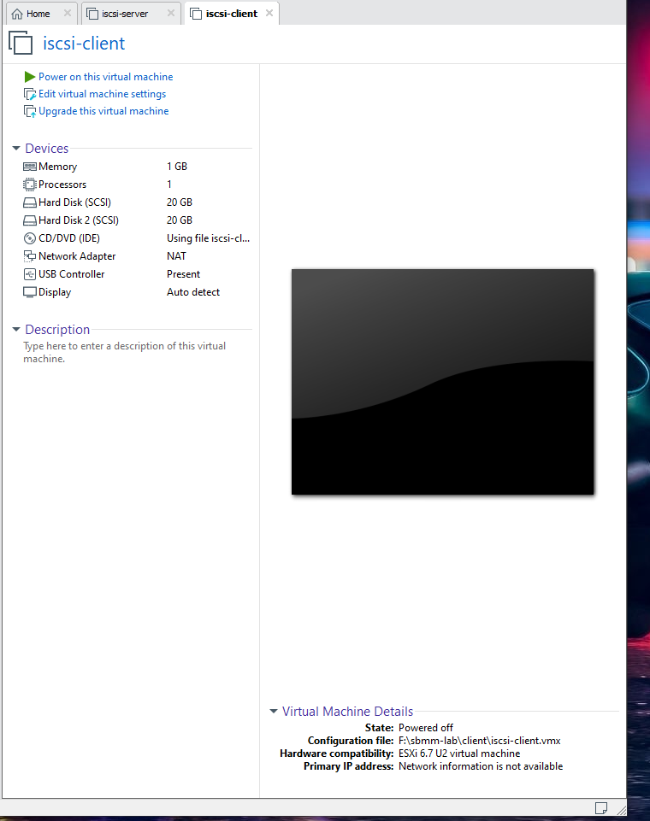

**---on both machine------**

systemctl stop firewalld

systemctl disable firewalld

vi /etc/selinux/config

disable

init 6

**on server machine------**

lsblk

pvcreate /dev/sdb /dev/sdc /dev/sdd

vgcreate vg_iscsi /dev/sdb /dev/sdc /dev/sdd

lvcreate -n lv_iscsi-disk-01 -L 1G vg_iscsi ------->>disk-01

lvs

lvcreate -n lv_iscsi-disk-02 -L 1G vg_iscsi ------->disk-02

yum install -y targetcli

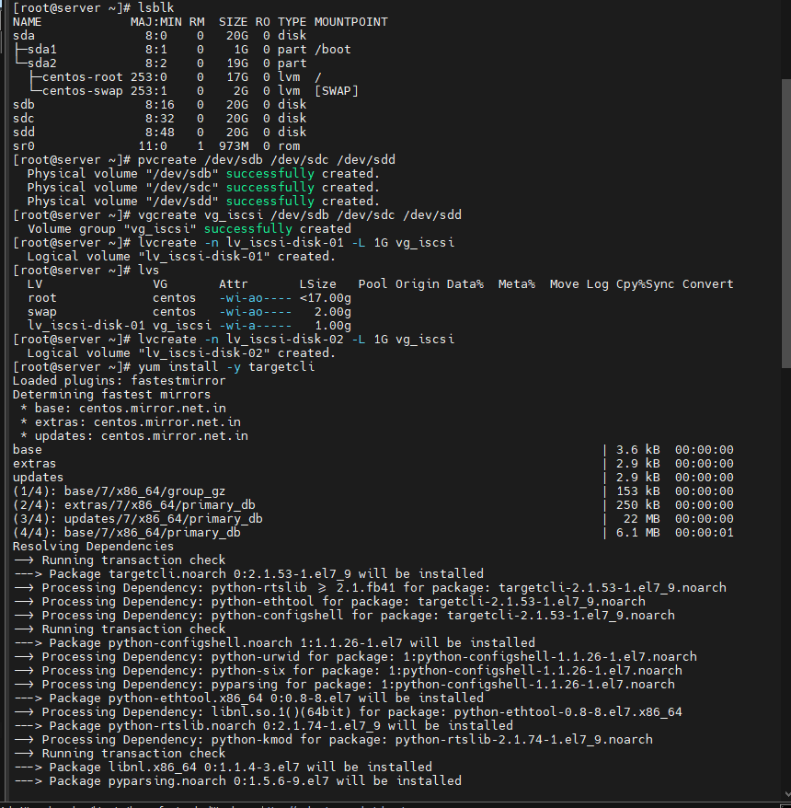

targetcli

cd backstores/block

create block1 /dev/mapper/vg_iscsi-lv_iscsi--disk--01

cd ..

ls

cd ..

cd iscsi

create iqn.2023-07.cdac.acts.hpcsa.sbm:disk1

cd iqn.2023-07.cdac.acts.hpcsa.sbm:disk1/

ls

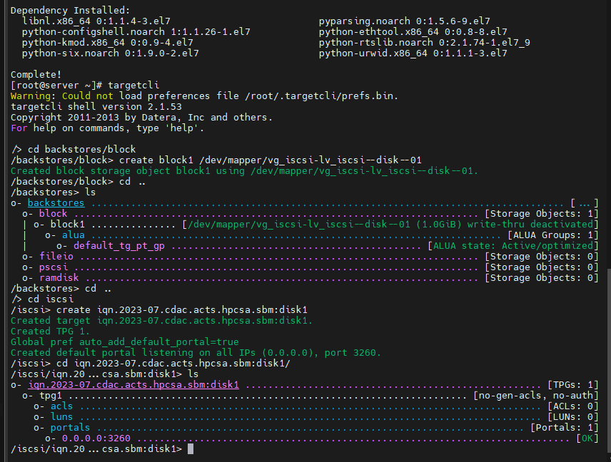

**Then go to client machine------**

yum install iscsi-initiator-utils –y

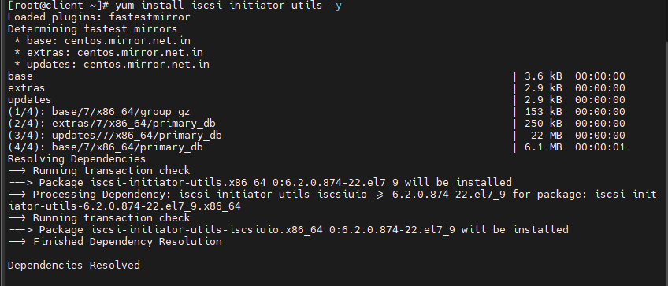

cat /etc/iscsi/initiatorname.iscsi

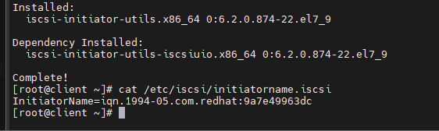

**goto server machine------**

cd tpg1/acls

create iqn.1994-05.com.redhat:9a7e49963dc

ls

cd ..

cd luns

ls

cd /

ls

exit

systemctl restart target

systemctl status target

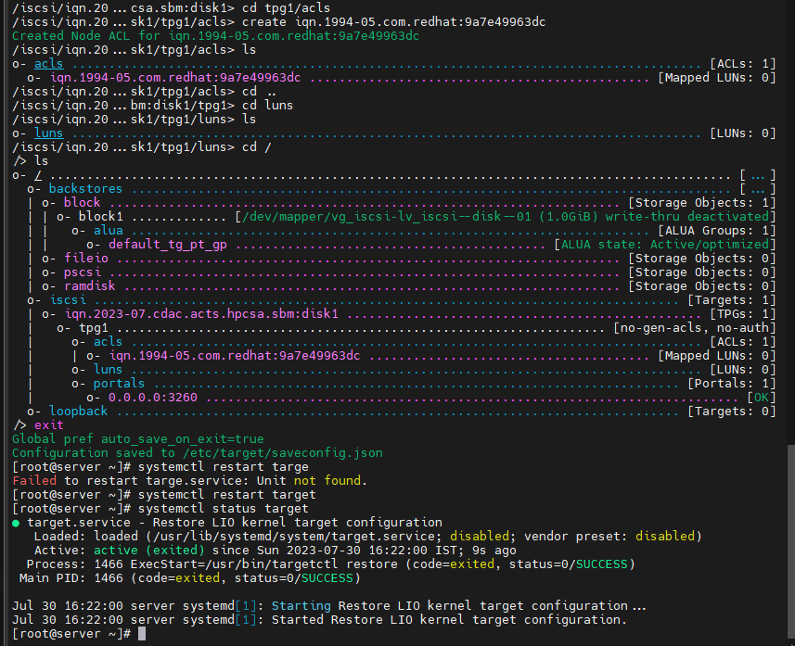

**on client machine-----**

systemctl start iscsi

iscsiadm -m discovery -t st -p 192.168.113.172 --login

lsblk

fdisk /dev/sdb

-> press n

-> press p

-> press enter

-> press enter

-> press w

mkfs.ext4 /dev/sdb1

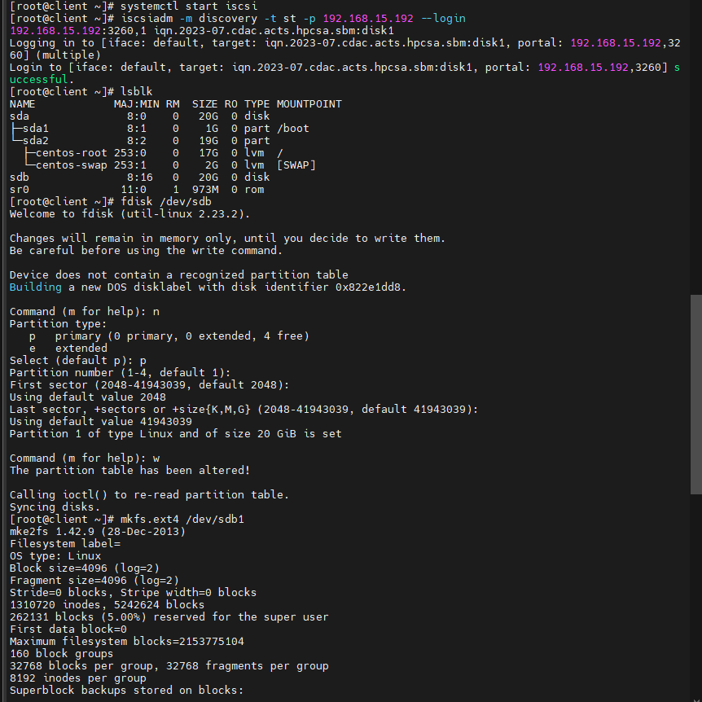

mkdir /mnt/iscsilab

mount /dev/sdb1 /mnt/iscsilab/

df -h

cd /mnt/iscsilab/

iscsiadm -m session

lsblk

dd if=/dev/zero of=file.test bs=1024 count=520040

lsblk

df –Th

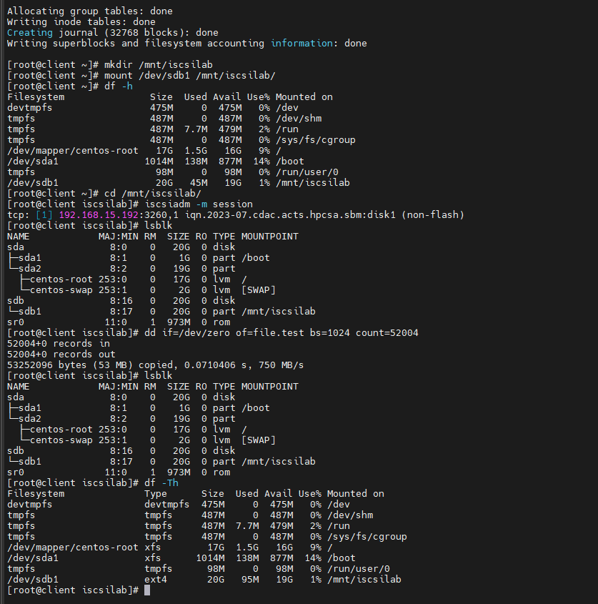

**Go to server machine –**

